Application form for category B Seats
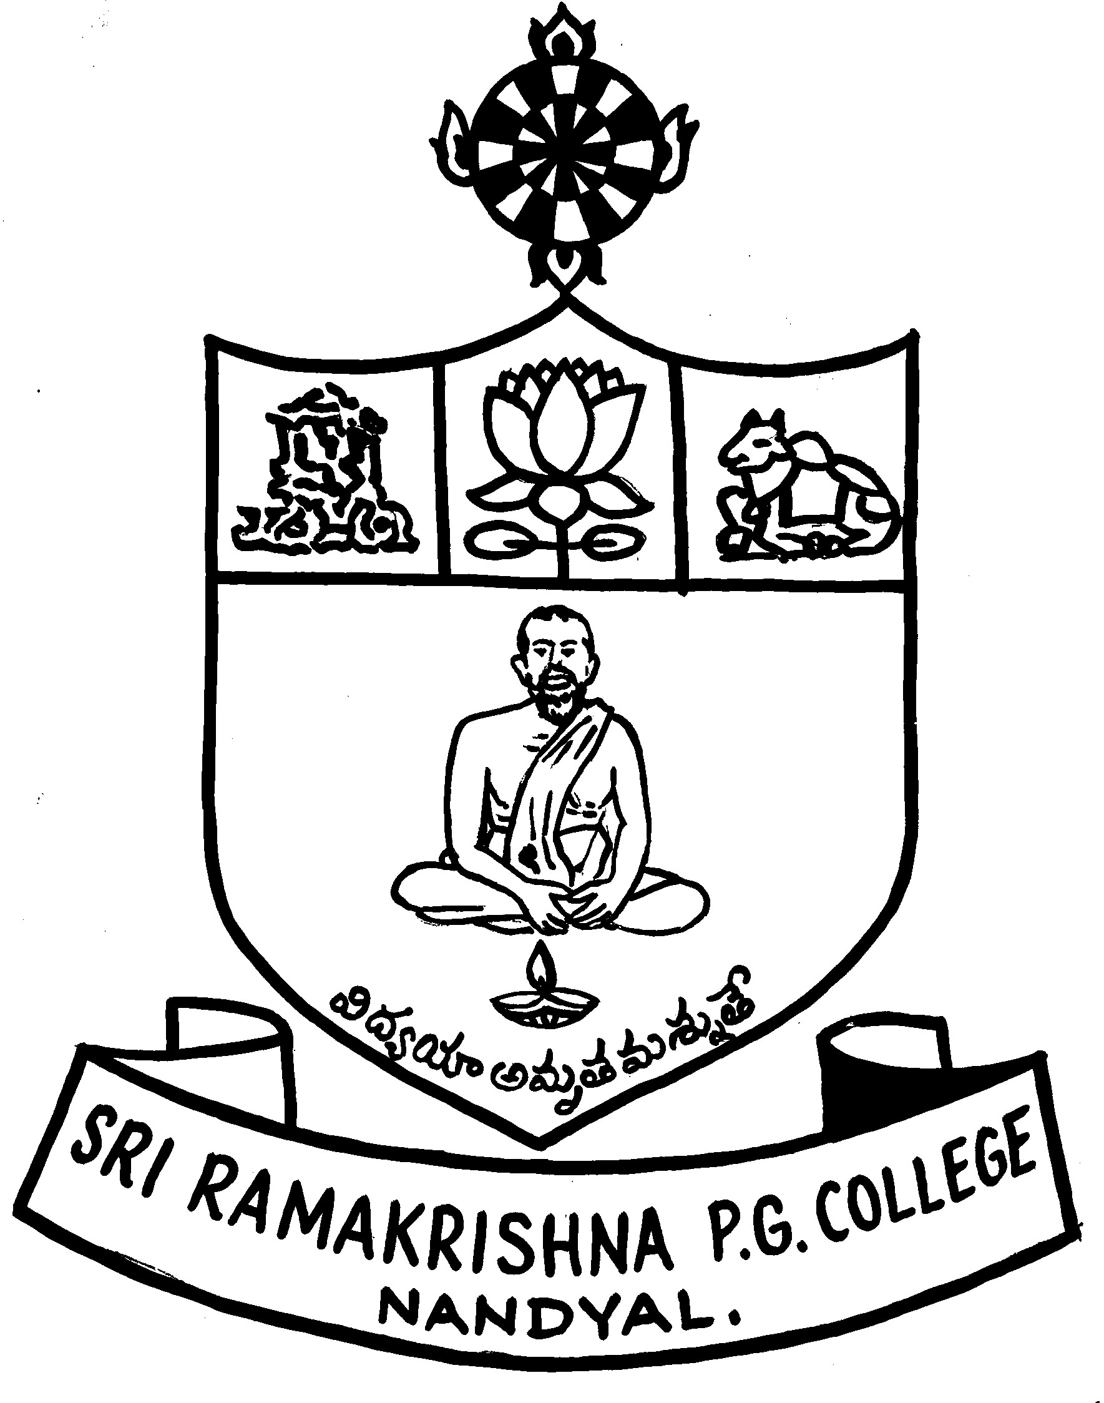
SRI RAMAKRISHNA P.G.COLLEGE:: NANDYAL
Recognized by Govt.of A.P and Affiliated to S.K.University,Anantapur
(Approved by A.I.C.T.E., Govt. of India, New Delhi)
ISO 9001 : 2000 Certified Institution

Note: All entries are to be filled by the students own handwriting in English BLOCK LETTERS. Use ✓ Mark in left side box of every option.

I.STUDENT PARTICULARS:

Surname Name
1. Name:

2. Date of Birth

Affix your resent Passport size color photograph

3. Sex: male Female

4. Nationaity: ◻Indian ◻others (specify) ______________

5. Religion: ◻ Hindu ◻ Muslim ◻ Christian ◻ Others

6. Caste: ______________

7. Category: ◻ Gen/OC ◻ BC-A/B/C/D/E ◻ SC ◻ ST ◻ Others __________

8. Blood Group: ________________

9. Residential Status: ◻ NRI ◻ Other States ◻ A.P

II COURSE PARTICULARS

1. Name of the Course: ◻M.C.A ◻M.B.A ◻ M.B.A (Finance)

2. Did you appear for Icet
if yes, Mention the Rank ________________

if No, Mention the Degree Percentage __________

III. Lower Degree / Qualifying Examination Details

Name of the Degree

Optional Subjects

Previous College Name & Place Last Studied

Year of Passing |  | Division |  | % of Marks

IV PARTICULARS OF THE PARENT / GAURDIAN

Name
Relationship
Occupation
Annual Income
Telephone Numbers  With STD Code | Land :  Cell :

Permanent Address:

`
Pin Code :

DECLARATION BY THE STUDENT

I declare that the particulars given by me above are correct. I will abide by the rules and regulations of the college relating to discipline, ragging and attendance and settle all types of dues to the college/university as stipulated. Further I shall bear the consequences if the particulars furnished by me are found to be false at any time in future.

Signature of the Student

DECLARATION BY THE PARENT/GUARDIAN

I here by state that I shall undertake to see that my son/ daughter/ward obey all the rules and regulations of the college and we do pay all fees as per the norms of the institute and the government.

Station:
Date: Signature of the parent/ Guardian

LIST OF CERTIFICATES ENCLOSED

1. 4.

2. 5.

- 6.

INSTRUCTIONS :

- The Registration fee of Rs 1500/- have to pay in the form of DD drawn is favour of The
Principal SRK P.G College, Nandyal is any nationalised Bank.

2. The last date for downloading & Submission of the application is 30/7/08.

